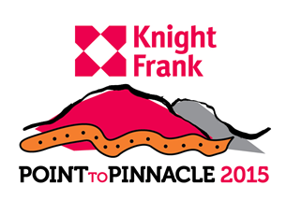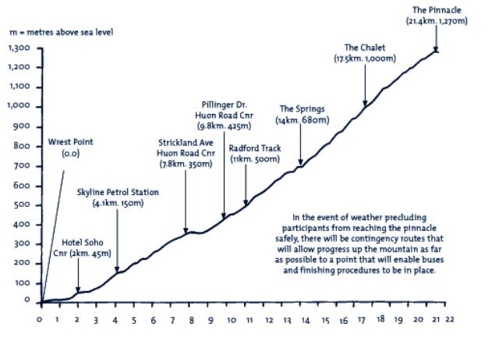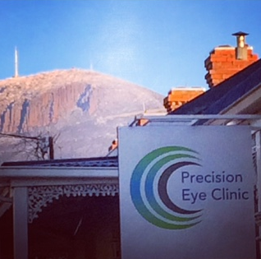

### We’re walking the point to pinnacle

* WE’RE NOT JUST WALKING

We’RE RAISING AWARENESS AND FUNDS FOR

GUIDE DOGS TASMANIA

IF YOU WOULD LIKE to show your support, we would appreciate your donation, no matter how big or small.